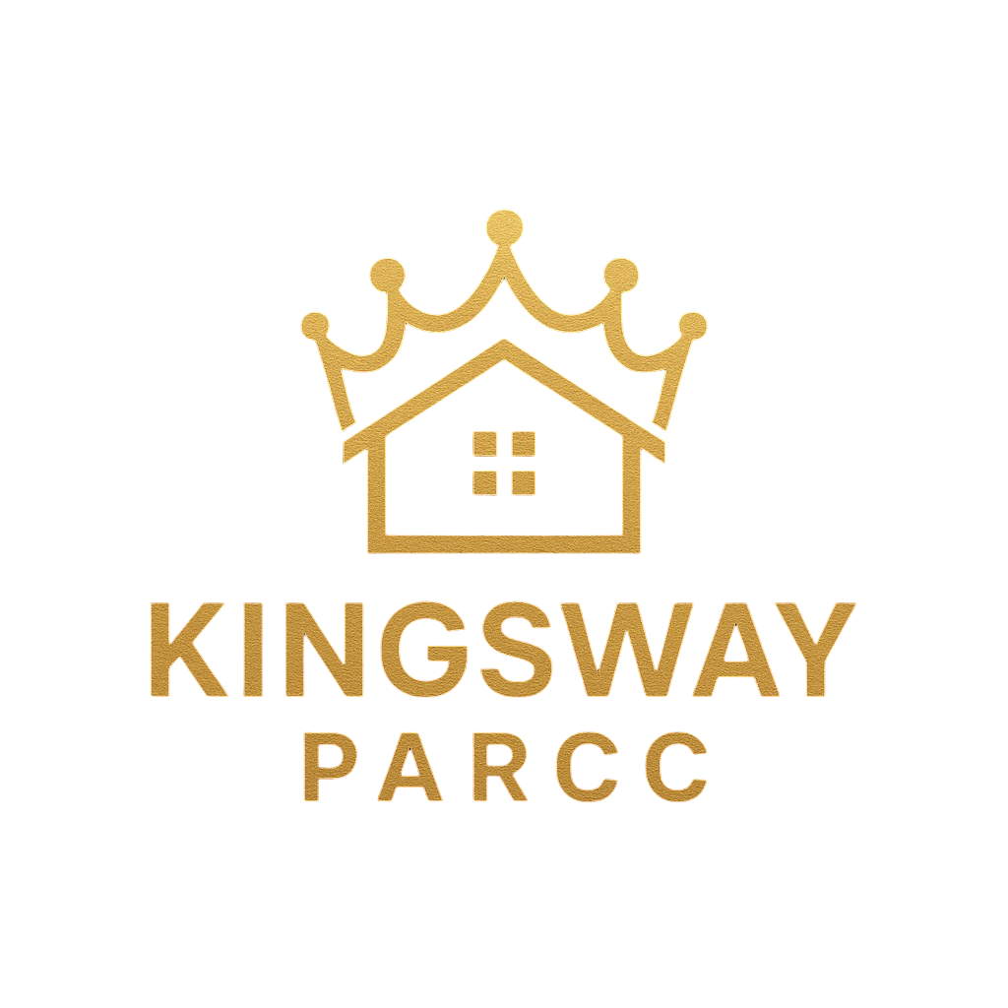

CREATE. STAGE. STYLE.

Building Stability. Inspiring Creativity.
Date: Sunday, September 6th, 2026
Location: La Familia Soundstage, 836 Guilford Ave, Baltimore, MD 21202
Artist Check-in & Setup: 4:00 PM – 5:00 PM
Event Hours: 5:00 PM – 10:00 PM

Vendor Information
Artist / Business Name: ________________________________________________

Contact Person: Person

Email Address: ________________________ Phone: ________________________

Brief Description of Offerings:
(Please describe the products, artwork, or services you will be providing)
__________________________________________________________________________________________________________________________________________________________________________
__________________________________________________________________________________________________________________________________________________________________________

Registration Options
Selection | Registration Type | Fee
☐ | General Vendor Registration | $100
☐ | AE1B Creator Registration | $75
☐ | Connections Bruncheon (Add-on) | $25

AE1B Creator Benefits
Artists registered as AE1B Creators receive the following exclusive professional advantages:

- Free promotion for merchandise, services, and upcoming events.
- Discounted rates for vendor tables and future event tickets.
- Exclusive invitations to contests, challenges, and giveaways.
- Full access to the First Key Navigation Network.
- Priority invitations to future artistic and professional opportunities.

Space & Equipment
- Included: One (1) Large Table OR Two (2) Small Tables and Two (2) Chairs.
- Artist Responsibility: Artists are responsible for all additional equipment needed for display, including tablecloths, extension cords, and specialized stands.

Liability & Media Release
Media Release: I grant Kingsway PARCC permission to photograph and record my booth, products, and participation for promotional, marketing, and educational purposes without compensation.

Liability Waiver: I voluntarily participate in this event and agree to release, indemnify, and hold harmless Kingsway PARCC and the venue partners from any claims, damages, or injuries arising from my participation. I am solely responsible for my products, setup, and sales.

Terms and Acknowledgement
I acknowledge that I have read and agree to all terms outlined in this registration form, including the liability waiver and media release. I confirm that all information provided is accurate and that I understand my responsibilities as a vendor for the Create. Stage. Style. event.

Signature: __________________________________ Date: Date

